Yatra
Yoga in the Temples of South India
with Vishali Varga, Vanessa Airey & Sarah Webb
June 25 – July 8th, 2026

This extraordinary trip led by Vishali Varga, Vanessa Airey & Sarah Webb, is an opportunity to immerse yourself deeply in the experience of Yatra, the yogic practice of traveling to the most sacred spaces in India. A yatra is not a ‘vacation’, but an engagement of the body, like asana, a demanding activity that allows one to experience stretching and re-balancing body, heart and mind.

A yatra is a ‘pilgrimage’ made with a particular intention to expand your own spiritual journey. In the year leading up to departure, we will study to prepare you the experience. While there, we will do our best to invigorate the body as our senses meet wonderous new experiences. An expanded mind and heart is guaranteed as we focus on opening to receive the gifts of this ancient culture.

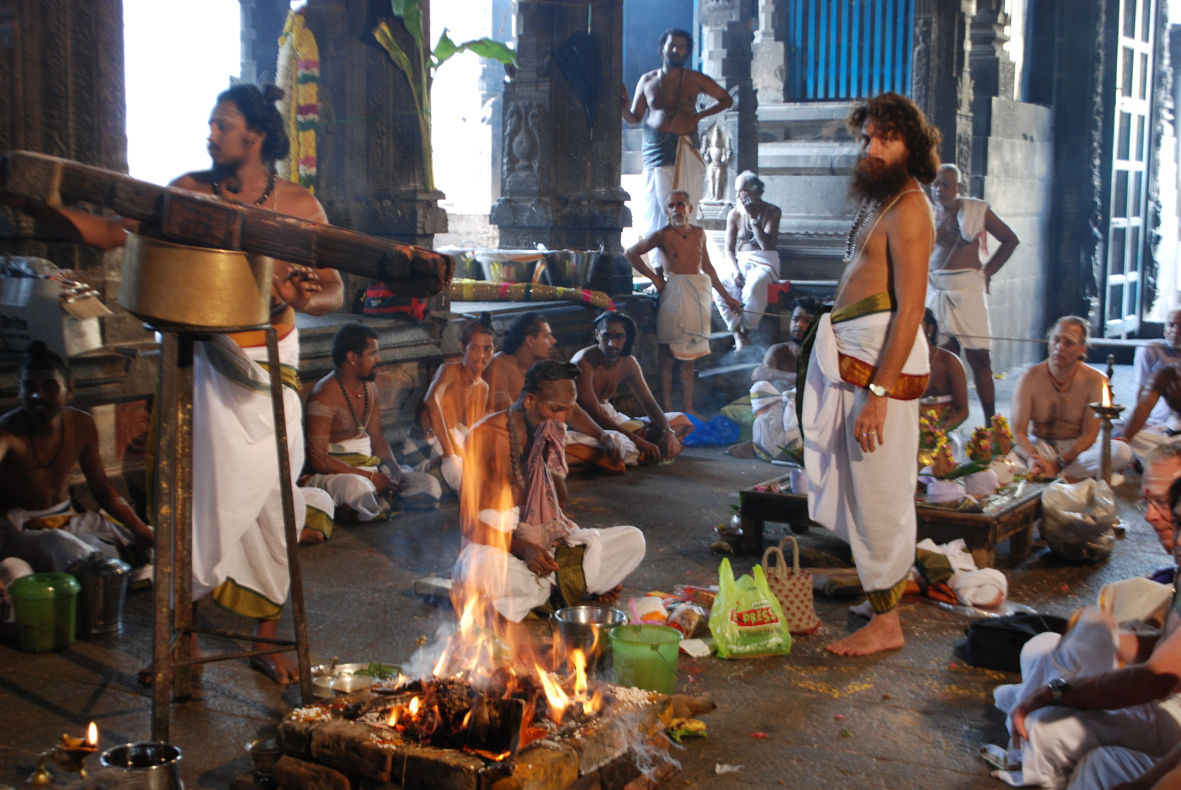

Indian temple culture holds profound practices often unknown in the West, where yoga is usually introduced through asana, Patanjali’s 8 limbs and cursory philosophical study. In reality, thousands of rituals, texts, and practices to support the path to realizing the bliss of the Self.

On this yatra, we travel through South India—one of the few places where ancient traditions remain alive and practiced for millennia. Here, we gain direct experience of a wisdom that is both timeless and urgently relevant today, but hidden in plain sight as experiencing and decoding the rituals requires interest and access.

The people, their myths, rituals, and way of life offer new ways of seeing the world and the Self. This journey goes beyond typical tours, opening a rare window into 2,000 years of living spiritual tradition still vibrant in South Indian temples.

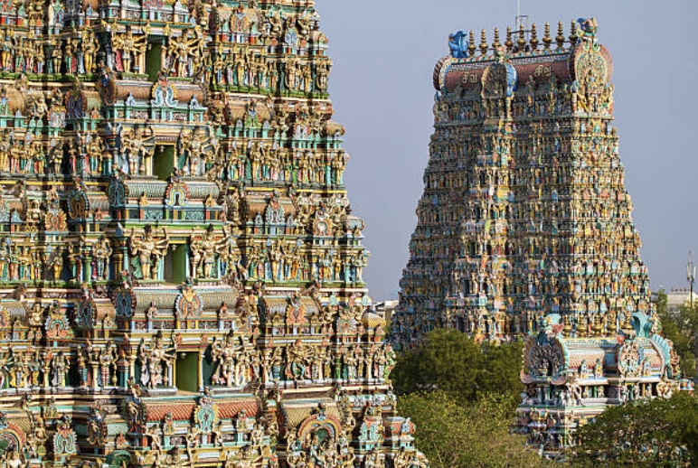

On this trip you’ll be travelling with leaders who will get us that access and provide the decoding necessary to take us deeply into the culture, deeply into the Self. We will dress in Indian clothes on yatra do, and because of this we will be welcomed as honored guests and thanked for taking the time to study and practice their ancient teachings – even the clothing is deeply meaningful. At each temple we will participate in the rituals of the temple deities.

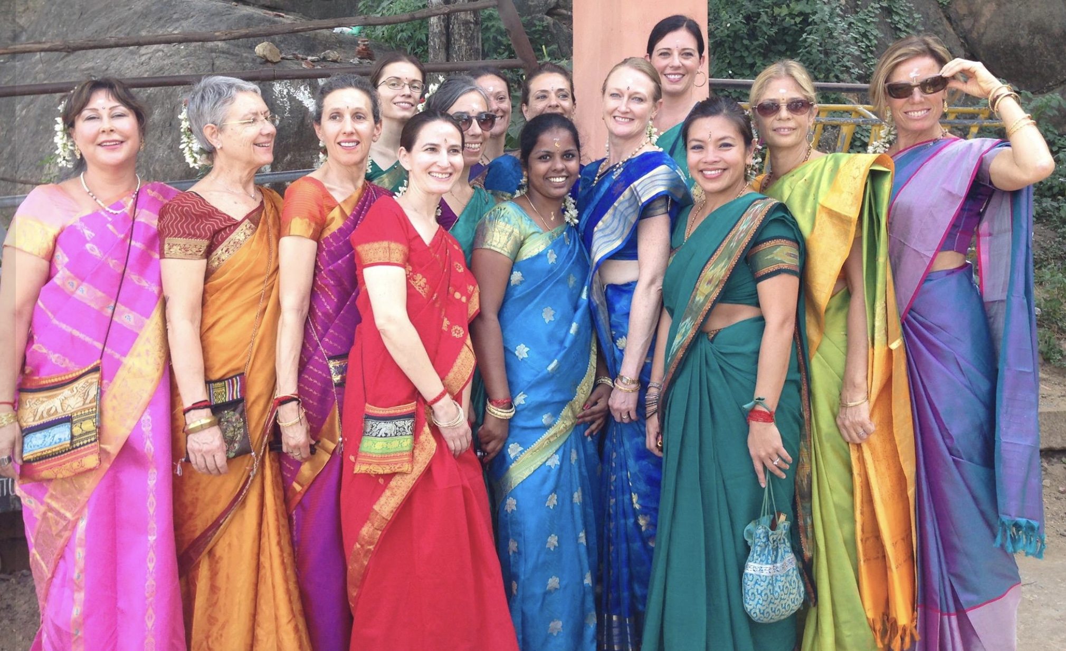

During mealtimes we will eat with the locals at small restaurants or at the homes of friends or priests. The yatra includes visits into daily life, to local schools, a rural village, cottage industries of weaving and bronze casting. All this will deepen your understanding of the power of cultural lineage in the practice of yoga.

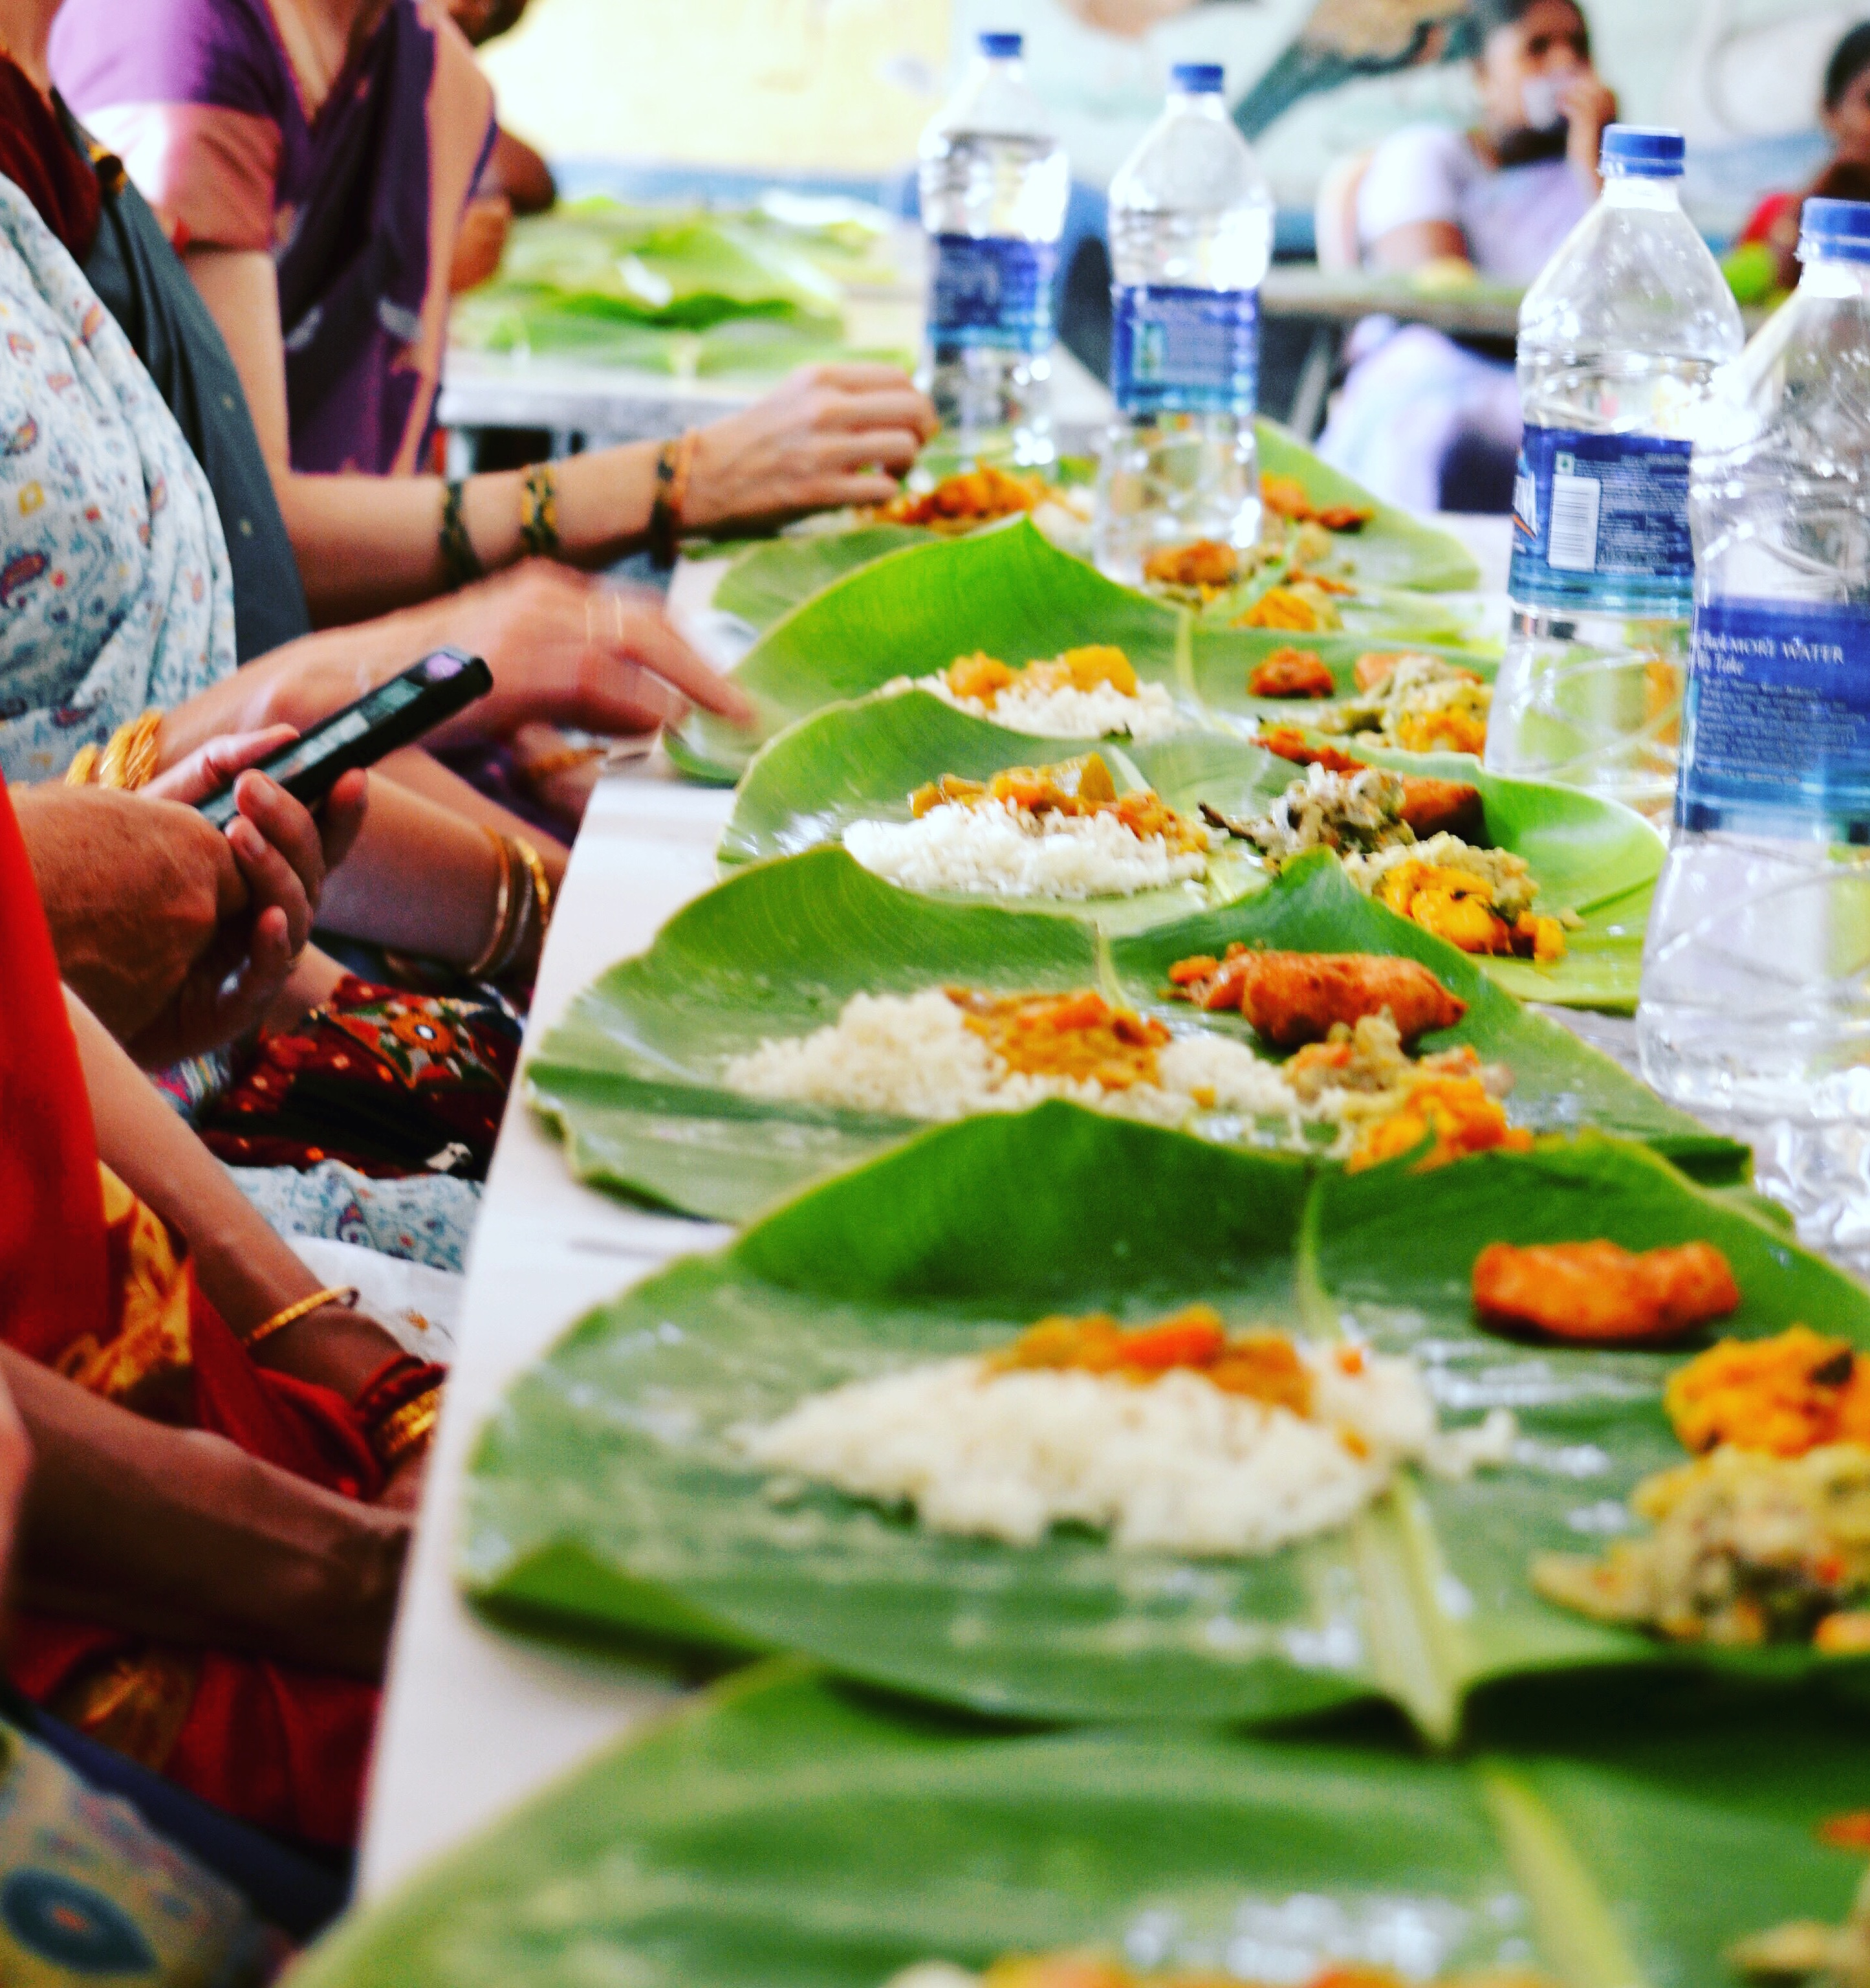

When we arrive in Chidambaram, the home of the Dancing Shiva Nataraja and unpack the important story of Kali, Patanjali, Shiva, Ganesha and the Goddess and how and why it’s cultural/political/socio/physio/religious heritage is relevant to us and a deeper understanding of the Self.

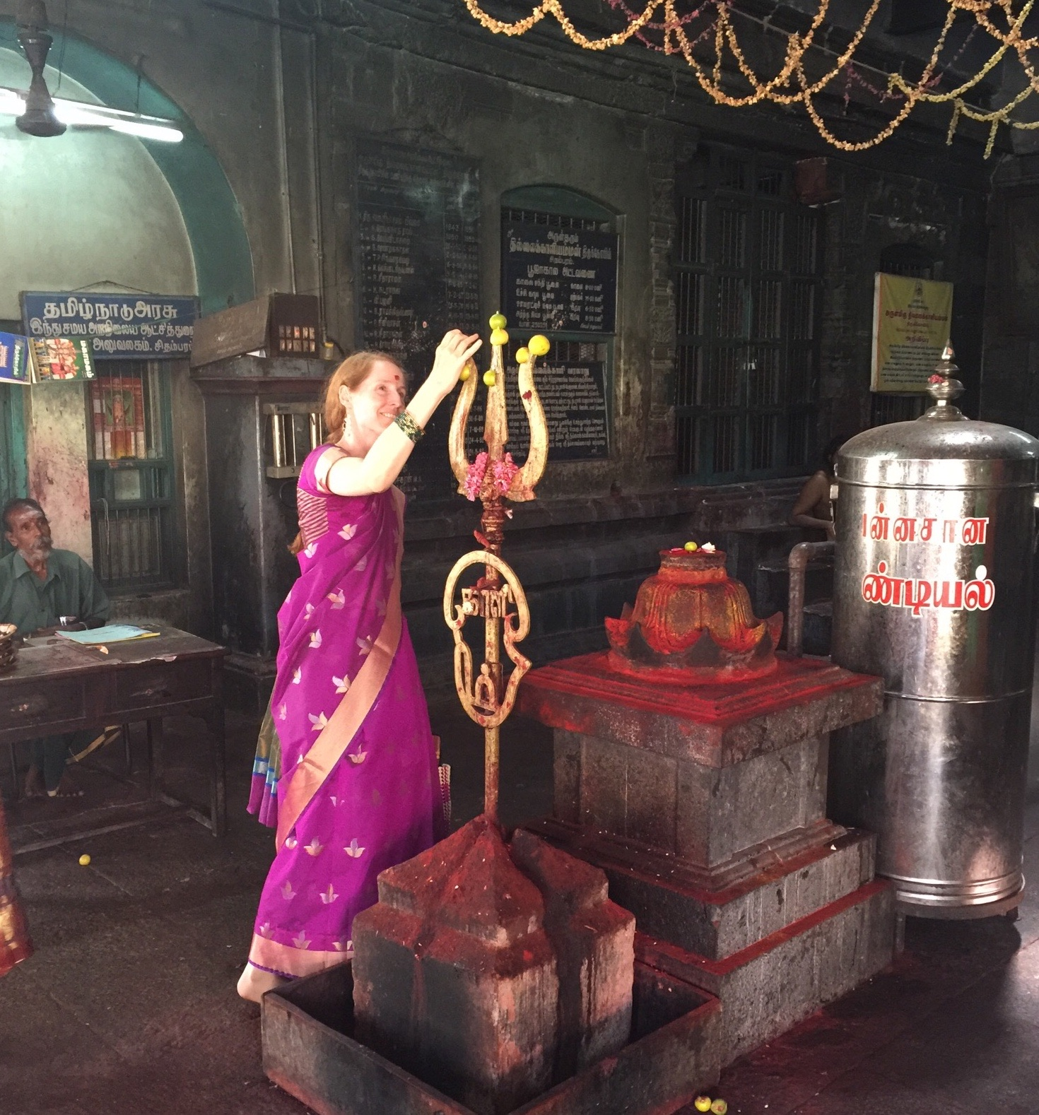

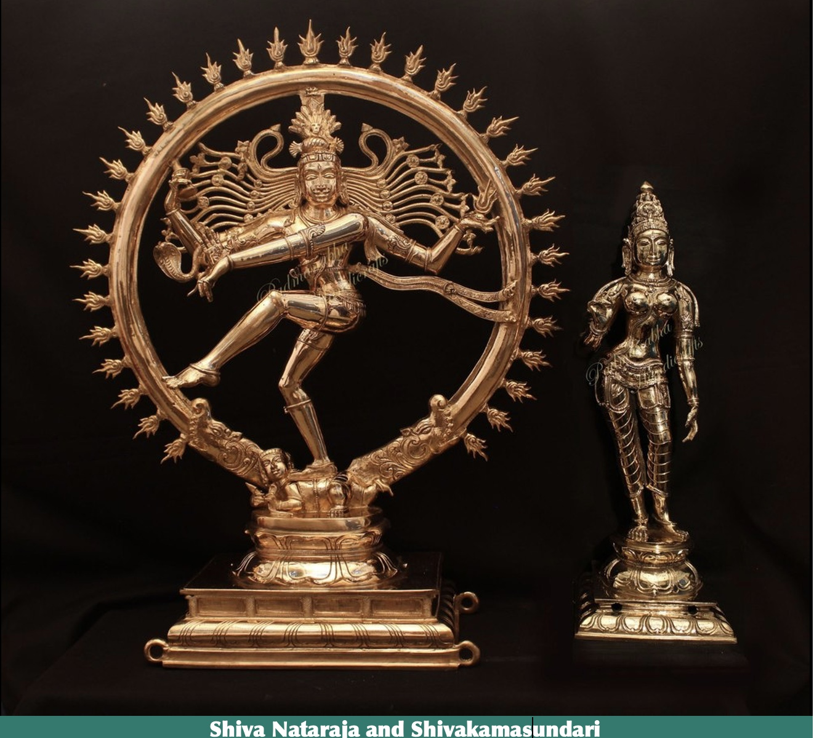

In 15 days you’ll have a lifetime of experiences to inspire and further your unfolding understanding of the vastness of yoga from the inside out.
To join u,s all you need is a steady heart, a tender mind and an adventurous spirit!

For more information please contact Vanessa, Sarah or
Vishali Varga at 561-573-5012, Vishali@VishaliVarga.com

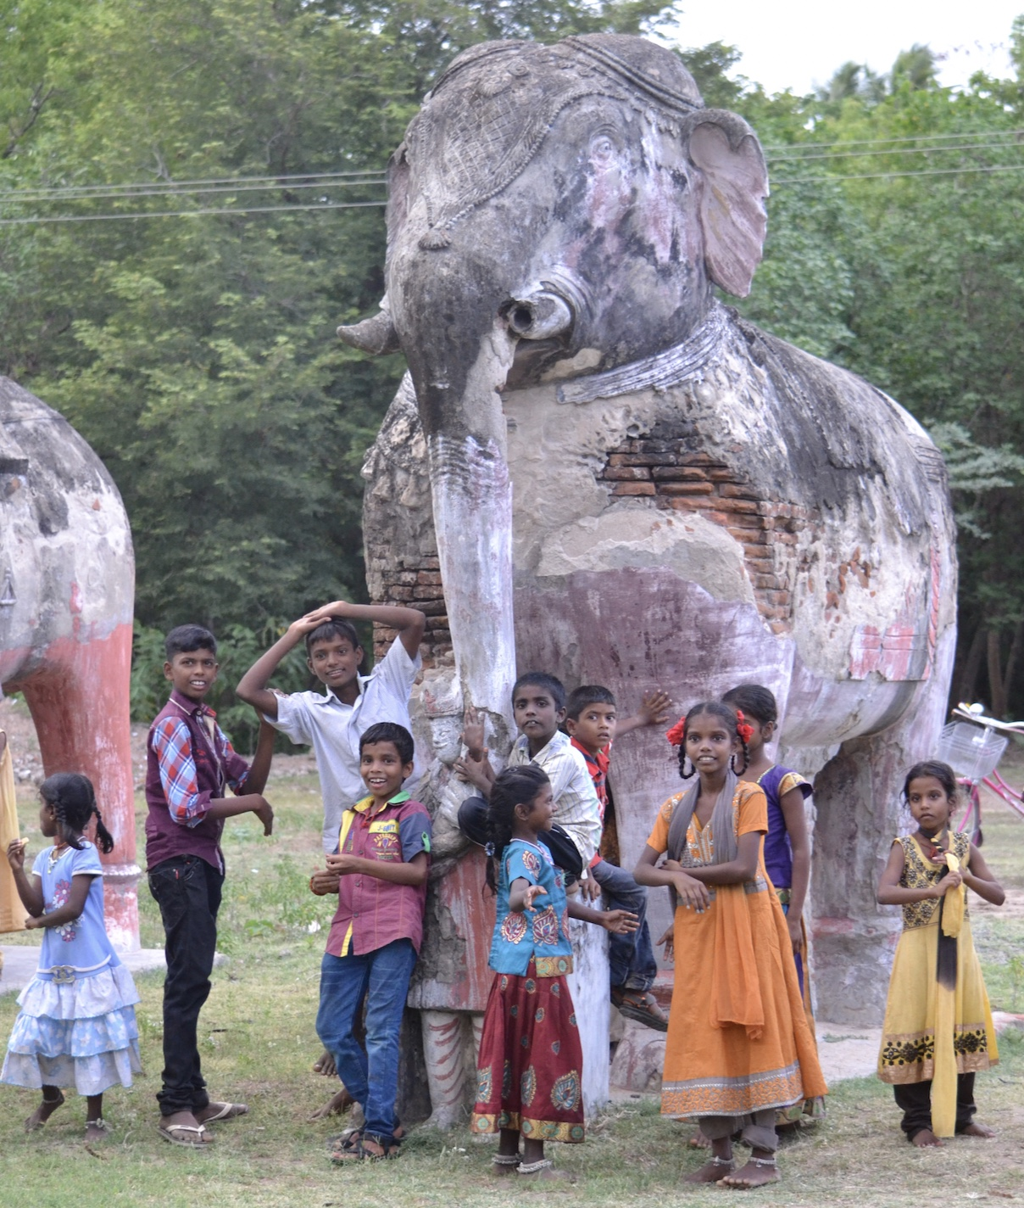
Prep for Pilgrimage
In order to support travelers in having the very best experience possible, we hold monthly prep sessions that include logistics, philosophy and practice. Join us for these monthly sessions whether or not your have completely committed to going.
Sessions are held Sundays from 5-6:30 pm: October 5; November 9; December 7; January 11; February 8; March 15; April 12; May 3; June 7
Zoom info: Meeting ID: 9946482527 Passcode: 989898

Sample Itinerary

June 25 Depart US (An inexpensive option: Air India flt 102 non-stop JFK arrives DEL 11 am 6/26.Then Indigo flt 2.20pm- arrives Chennai 5:10 pm

June 26 Arrive in Chennai 5:10 pm
Drive to Thiruvannamalai
Dinner & Bed
Stay Thiruvannamalai Sparsha Resort

June 27 Thiruvannamalai
Morning Asana & Satsang
Afternoon trip to Temple
Stay Thiruvannamalai Sparsha Resort

June 28 Thiruvannamalai - Kanchi
Morning Asana & visit to Samadhi Shrine
Drive to Kanchipuram
Evening Darshan at Ekambeshwar
Evening Satsang
Stay Kanchipuram

June 29 Kanchipuram
Morning visit Kamakshi Ekambehswara Temple
Drive to Chidambaram in afternoon
Evening Satsang & Ardha Janma
Stay Chidambaram

June 30 Chidambaram –
Morning visit to temple
Satsang
Thillai Kaliamman
Afternoon Mariamman
Evening Coconuts with Ganesh
Ardha Janma
Stay Chidambaram

July 1 Chidambaram
Homa
Stay Chidambaram

July 2 Chidambaram
Morning – Rest/Darshan
Afternoon – Satsang
Evening – Ardha Janma
Stay Chidambaram

July 3 Chidambaram – Kumbakonam
Morning Thillai Kali Amman
drive to rural Village for lunch and school visit
Afternoon- Satsang & Spa Treatments
Stay Kumbakonam Resort

July 4 Kumbakonam
Morning Asana
Sw. Malai/Bronze makers
Lunch in town
Afternoon Spa treatments
Stay Kumbakonam Resort

July 5 Kumbakonam
Morning asana/Satsang
Pratyanghira, Adhi Kumbeshwara temples
Evening Thiruvarau Temple
Stay Kumbakonam Resort

July 5 Kumbakonam –Trichy - Madurai
Visit Mariamman, Jambhukeshwar, Vekkaliamman
Stay Madurai Resort

July 6 Madurai
Meenakshi Temple / Shop at Emporium
Stay Madurai Resort
July 7 Madurai
Fly from Madurai to Delhi

July 8 RECOMMENDED FLIGHT Delhi-JFK Air India flt 101. 2 am
Arrive Home July 8th 11:30 am

Logistics:
Early Bird Pricing saves $400!
Sign up with $825 deposit before Oct 12! PP Double Occupancy: $4295 Single $5395

Price Oct 12, 2025 after: PP Double Occupancy $4695 ; Single Occupancy $5795
All hotels have private bath and air conditioning;
Upon Arrival we travel by deluxe air-conditioned coach

To reserve your spot:
Deposit: $825 can pay by cash, check, Zelle, Venmo or credit card (with 3.5% fee)
Monthly payment plan is available: All Payments must be made by April 12, 2026

What is not included: Airfare, Tips and donations, Lunch and dinners, Indian clothing. A “savings friendly” spending plan will be provided for budgeting purposes in the training.

Trip will include:
Satsang and deeper teachings into the rituals and practices of Yoga
Asana Practice
Ritual Attendance

Sari Shopping
Sari wrapping
Bronze Casting
Cotton & silk loom visit
Visit to 19th century mansions of ancient trading Caste
Rural village visit with lunch
Temple visits:
Hindu deities: Kali, Nataraja, Krishna, Lakshmi, Ganapati, Murugan & more
Rituals: Homa, abhishekam, darshan, pradakshina, and more….explained and practiced
Hike to meditation cave
Elephant rides
Shopping
Swimming
Spa services (fees not included) available at some hotels
Priest Home visit
Rural Village and School visit

